Use the following steps to access the page where you can view and manage user states:

1. Sign in to the [Azure portal](https://portal.azure.com/) as an administrator.
2. Go to **Azure Active Directory** > **Users and groups** > **All users**.
3. Select **Multi-Factor Authentication**.
4. A new page that displays the user states opens.

Change the status for a user

1. Use the preceding steps to get to the Azure Multi-Factor Authentication **users** page.
2. Find the user you want to enable for Azure MFA. You might need to change the view at the top.
3. Check the box next to their name.
4. On the right, under **quick steps**, choose **Enable** or **Disable**. 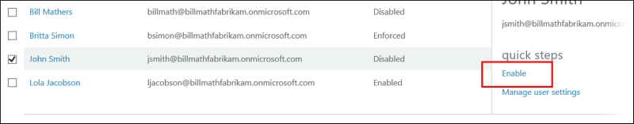

Tip

*Enabled* users are automatically switched to *Enforced* when they register for Azure MFA. Do not manually change the user state to *Enforced*.

1. Confirm your selection in the pop-up window that opens.